

UTHAI-Humanoid

**Assembly manual**

Version [0.0.1]

Modified: 2018/2/25

Principle authors:

taa

Bird

Liews

# Parts list 1 - Frame

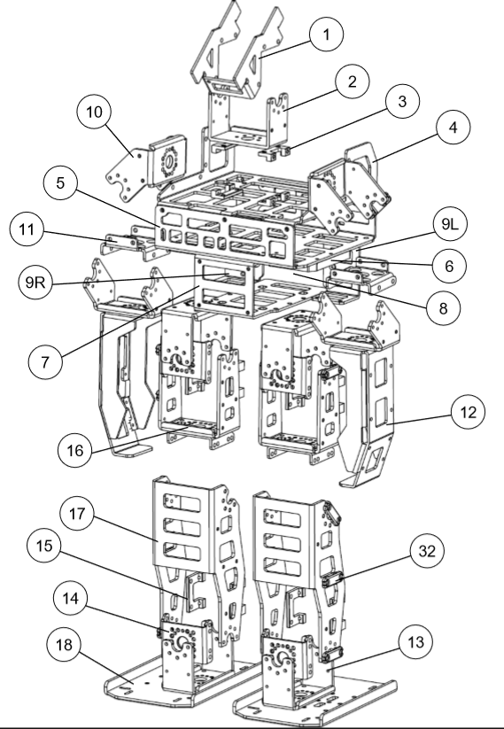

| Part Number | Description | Part Name | Qty. |
| --- | --- | --- | --- |
| 1 | Batter Bracket | UH_00192 | 1 |
| 18 | Foot | UH_R_F | 2 |
| 2 | Thigh Bracket | UH_R_TH | 2 |
| 3 | Knee Bracket | UH_R_KN | 2 |
| 18 | Foot | UH_R_F | 2 |
| 1 | Batter Bracket | UH_00192 | 1 |
| 18 | Foot | UH_R_F | 2 |
| 2 | Thigh Bracket | UH_R_TH | 2 |
| 3 | Knee Bracket | UH_R_KN | 2 |
| 18 | Foot | UH_R_F | 2 |
| 3 | Knee Bracket | UH_R_KN | 2 |
| 18 | Foot | UH_R_F | 2 |
| 3 | Knee Bracket | UH_R_KN | 2 |
| 18 | Foot | UH_R_F | 2 |

# Parts list 2 – Actuators

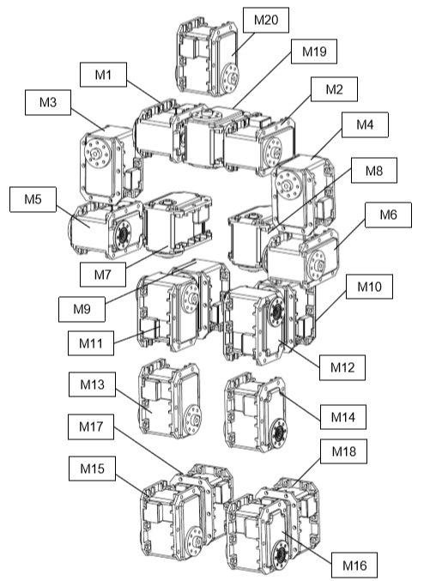

| ID | Name | Actuator Type | Bearing Required |
| --- | --- | --- | --- |
| M1 | R_hip_yaw | Dynamixel EX-106+ | No |
| M2 | R_hip_roll | Dynamixel EX-106+ | No |
| M3 | R_hip_pitch | Dynamixel EX-106+ | No |
| M4 | R_knee_pitch | Dynamixel EX-106+ | No |
| M5 | R_ankle_pitch | Dynamixel EX-106+ | No |
| M6 | R_ankle_roll | Dynamixel EX-106+ | No |
| M11 | L_hip_yaw | Dynamixel EX-106+ | No |
| M12 | L_hip_roll | Dynamixel EX-106+ | No |
| M13 | L_hip_pitch | Dynamixel EX-106+ | No |
| M14 | L_knee_pitch | Dynamixel EX-106+ | No |
| M15 | L_ankle_pitch | Dynamixel EX-106+ | No |
| M16 | L_ankle_roll | Dynamixel EX-106+ | No |
| M21 |  |  |  |
| M22 |  |  |  |
| M31 |  |  |  |
| M32 |  |  |  |

# Parts list 3 – Electronics

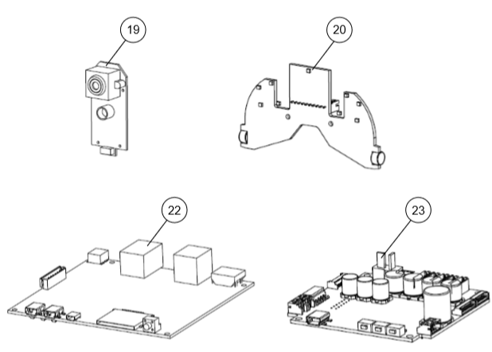

| Part Number | Description | Qty. |
| --- | --- | --- |
| 22 | Nucleo F411RE | 1 |
| 23 | Dynamixel Shield | 1 |
| 24 | Odroid XU4 | 1 |
| 25 | Battery | 1 |
| 26 | Speaker | 1 |
| 27 | Power Switch | 1 |

# Parts list 4 – Fasteners

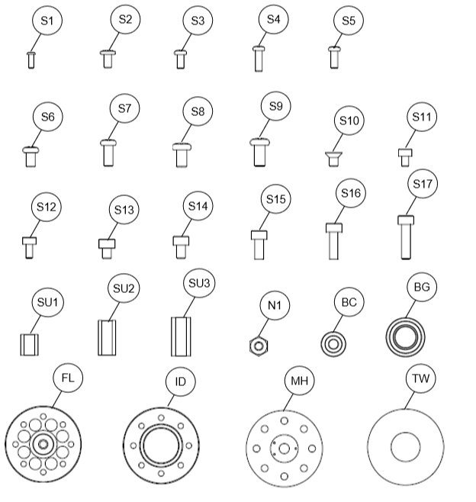

| Part Number | Description | Qty. |
| --- | --- | --- |
| S1 | HEX Head M2.5x10 | 112 |
| S2 | HEX Head M2.5x10 | 1 |
| S3 | HEX Head M2.5x10 | 1 |
| S4 | HEX Head M2.5x10 | 1 |
| S5 | HEX Head M2.5x10 | 1 |
| S6 | HEX Head M2.5x10 | 1 |

## 0 – Actuators

Dynamixel EX-106+ Actuator ID’s are recommended to be set prior to assembly.

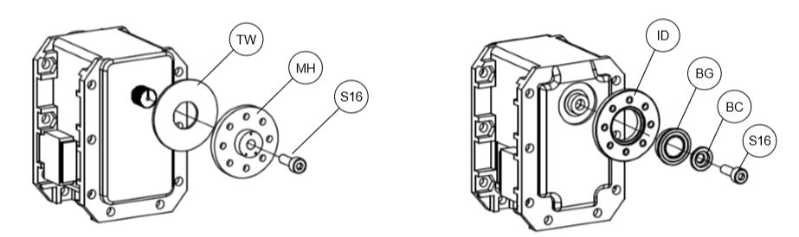

#### Horn attachment

All actuators require horn

Actuator bearing attachment

M1, M2, M3, M4, M5, …, do NOT require a bearing

### [Warning]

Horns must align with actuator shaft. Damage to actuators and/or robot may occur if horn is not properly aligned when attached to actuator.

# 1 – UTHAI Chest

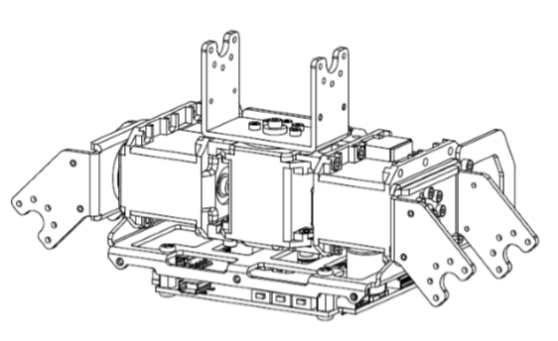

| Part Number | Description | Qty. |
| --- | --- | --- |
| S1 | HEX Head M2.5x10 | 112 |
| S2 | HEX Head M2.5x10 | 1 |
| S3 | HEX Head M2.5x10 | 1 |
| S4 | HEX Head M2.5x10 | 1 |
| S5 | HEX Head M2.5x10 | 1 |
| S6 | HEX Head M2.5x10 | 1 |

## 1.1 Uthai chest -> Actuators assembly

## 1.2 Uthai chest -> Electronics assembly

## 1.3 Uthai chest -> Unit Assembly

# 2 – UTHAI Pelvis

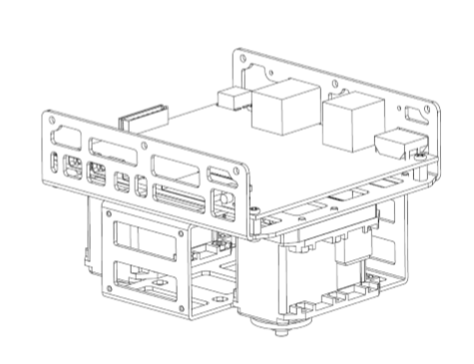

| Part Number | Description | Qty. |
| --- | --- | --- |
| S1 | HEX Head M2.5x10 | 112 |
| S2 | HEX Head M2.5x10 | 1 |
| S3 | HEX Head M2.5x10 | 1 |
| S4 | HEX Head M2.5x10 | 1 |
| S5 | HEX Head M2.5x10 | 1 |
| S6 | HEX Head M2.5x10 | 1 |

## 2.1 Uthai PELVIS -> Actuators assembly

## 2.2 Uthai pelvis -> Unit assembly

# 3 – UTHAI Right leg

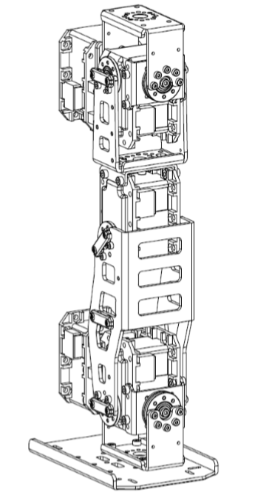

| Part Number | Description | Qty. |
| --- | --- | --- |
| S1 | HEX Head M2.5x10 | 112 |
| S2 | HEX Head M2.5x10 | 1 |
| S3 | HEX Head M2.5x10 | 1 |
| S4 | HEX Head M2.5x10 | 1 |
| S5 | HEX Head M2.5x10 | 1 |
| S6 | HEX Head M2.5x10 | 1 |

## 3.1 Uthai RIGHT leg -> Lower leg

## 3.2 Uthai RIGHT leg -> UPPER leg

## 3.3 Uthai RIGHT leg -> UNIT ASSEMBLY

# 4 – UTHAI LEFT leg

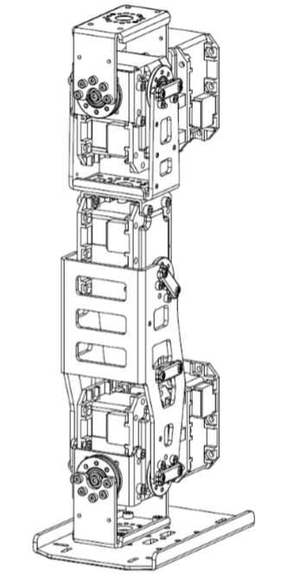

| Part Number | Description | Qty. |
| --- | --- | --- |
| S1 | HEX Head M2.5x10 | 112 |
| S2 | HEX Head M2.5x10 | 1 |
| S3 | HEX Head M2.5x10 | 1 |
| S4 | HEX Head M2.5x10 | 1 |
| S5 | HEX Head M2.5x10 | 1 |
| S6 | HEX Head M2.5x10 | 1 |

## 4.1 Uthai LEFT leg -> Lower leg

## 4.2 Uthai LEFT leg -> UPPER leg

## 4.3 Uthai LEFT leg -> UNIT ASSEMBLY

# 5 – UTHAI RIGHT ARM

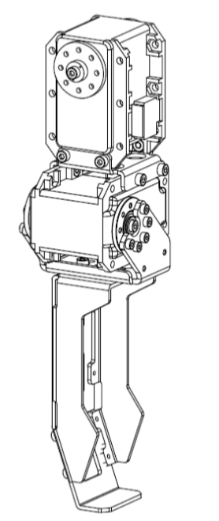

| Part Number | Description | Qty. |
| --- | --- | --- |
| S1 | HEX Head M2.5x10 | 112 |
| S2 | HEX Head M2.5x10 | 1 |
| S3 | HEX Head M2.5x10 | 1 |
| S4 | HEX Head M2.5x10 | 1 |
| S5 | HEX Head M2.5x10 | 1 |
| S6 | HEX Head M2.5x10 | 1 |

## 5.1 Uthai RIGHT ARM -> UNIT Assembly

# 6 – UTHAI LEFT ARM

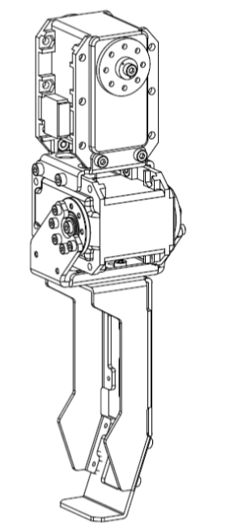

| Part Number | Description | Qty. |
| --- | --- | --- |
| S1 | HEX Head M2.5x10 | 112 |
| S2 | HEX Head M2.5x10 | 1 |
| S3 | HEX Head M2.5x10 | 1 |
| S4 | HEX Head M2.5x10 | 1 |
| S5 | HEX Head M2.5x10 | 1 |
| S6 | HEX Head M2.5x10 | 1 |

## 6.1 Uthai LEFT ARM -> UNIT Assembly

# 7 – UTHAI Full assembly

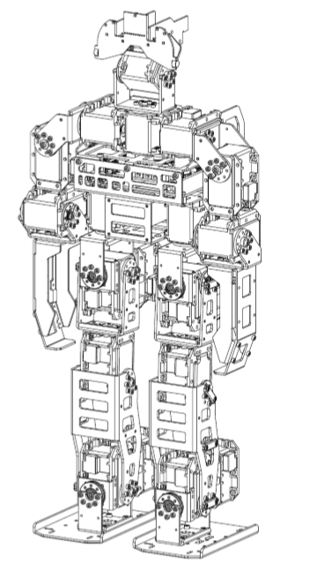

| Part Number | Description | Qty. |
| --- | --- | --- |
| S1 | HEX Head M2.5x10 | 112 |
| S2 | HEX Head M2.5x10 | 1 |
| S3 | HEX Head M2.5x10 | 1 |
| S4 | HEX Head M2.5x10 | 1 |
| S5 | HEX Head M2.5x10 | 1 |
| S6 | HEX Head M2.5x10 | 1 |

## 7.1 Uthai FULL Assembly -> Chest Assembly

## 7.2 Uthai FULL Assembly -> Pelvis Assembly

## 7.3 Uthai FULL Assembly -> Arms Assembly

## 7.4 Uthai FULL Assembly -> LEGS Assembly

## 